**Hypothesis testing** is an act in statistics whereby an analyst tests an assumption regarding a population parameter. The methodology employed by the analyst depends on the nature of the data used and the reason for the analysis. Hypothesis testing is used to infer the result of a hypothesis performed on sample data from a larger population.

*KEY TAKEAWAYS*

* *Hypothesis testing is used to infer the result of a hypothesis performed on sample data from a larger population.*
* *The test tells the analyst whether or not his primary hypothesis is true.*
* *Statistical analysts test a hypothesis by measuring and examining a random sample of the population being analyzed.*

Here’s a look at two commonly used hypothesis tests:

**One-Sample Test**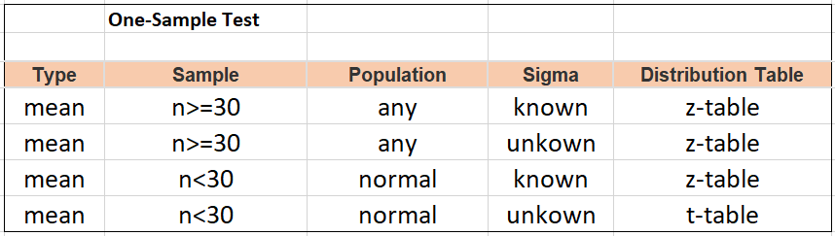

**Two-Sample Test**

